A Holistic Disease Prediction System with Machine Learning
Manav Patel ,Priyal Shah, Dwij Patel ,Shlok Patel and Sachi Joshi
¹ ² ³ ⁴ Computer Engineering Department, Devang Patel Institute of Advance Technology and Research, Charotar University of Science and Technology, Changa, Anand, 388421, Gujarat, India.
manav896939@gmail.com
priyalshah2307@gmail.com
dwij2123@gmail.com
shlokpatel598@gmail.com
sachi20shah@gmail.com
Abstract. To address time constraints in healthcare, we are launching a machine learning project to identify patients with serious diseases like heart disease, diabetes, pneumonia, and brain tumors early on. This will allow for timely and efficient treatment. By meticulously gathering, examining, and purifying diverse datasets, we identified the best methods and attained noteworthy precision. The utilization of state-of-the-art technologies guarantees reliable and accurate forecasts for all four models, and the easy-to-use Flask website streamlines the procedure, potentially saving patients' and medical professionals' lives by facilitating early disease identification. This initiative bridges the gap between the most recent diagnostic tools and urgent healthcare services by combining machine learning, data analytics, and data science.
Keywords: Heart disease, diabetes, brain tumor, pneumonia, machine learning
- INTRODUCTION
Healthcare is not an exception to the rise in information output in our information-driven world, where information is a valued asset. Patient data, which includes a wealth of historical and current medical information, is essential to the delivery of healthcare. Nevertheless, a fragmented approach to health analytics has resulted from the tendency of traditional illness prediction models to be customized for specific diseases [1]. Every illness, including diabetes, brain tumors, heart disease, and pneumonia, has a different prediction model associated with it [1]. One major shortcoming in the area is the absence of a unified approach for evaluating different diseases at once. To address this difficulty, we describe a novel architecture that uses user-inputted symptoms to predict these crucial diseases in a fast and accurate manner. This study aims to predict diabetes, heart disease, brain tumors, and pneumonia. Here, disease identification is accomplished using a variety of classification algorithms, including SVM, Random Forest, Logistic Regression, and Decision Trees [1]. To determine which method is optimal for prediction, the accuracy of each is verified and contrasted with one another. Since our architecture is so flexible, it will allow for the addition of other illnesses in the future. This method's primary benefit is that it saves consumers from having to seek across several sites for illness forecasts. This adaptable system has an easy-to-use user interface and employs Streamlit machine learning methods [1]. Users of our system input the name of the disease they are evaluating along with disease-specific parameters. The system then uses the matching model to evaluate the patient's condition as soon as possible.
  - CURRENT HEALTHCARE SYSTEM
Current healthcare systems rely on diagnosing individual diseases, which is a significant restriction. For instance, there are systems devoted to the study of diabetes, diabetic retinopathy, and the prediction of heart disease. Because of this caring approach, healthcare institutions now use a variety of disease-specific models to appropriately evaluate patient health data [2]. Present methods perform a great job of diagnosing individual diseases, but they are insufficient for a thorough examination of several diseases on one platform [2]. Enhancing disease prediction and offering a one-stop shop where consumers don't have to search through several platforms to find probable health issues are our primary objectives. Our goal is to enable medical practitioners to improve overall prognosis by decreasing misdiagnosis and increasing cross-checking of diagnoses.

  - PROBLEM STATEMENT
In the healthcare sector, an integrated system that is capable of concurrently diagnosing and predicting many illnesses is desperately needed. The predominant focus of current medical analytics models is on specific diseases, which makes it challenging for patients and healthcare providers to switch between many specialized platforms [2]. The absence of a clear answer leads to delayed diagnoses, lost chances for early intervention, and a higher chance of misdiagnosis, all of which have an impact on patient outcomes and raise healthcare expenses. Our research is to build a reliable and effective method to anticipate and diagnose many diseases inside a single framework by utilizing cutting-edge methods and machine learning. The ultimate objective is to enhance patient outcomes and treatment.
- LITERATURE REVIEW
Sahil Chaudhari et.al [1] in their app can assist in the early detection and prevention of illnesses including diabetes, cardiac arrest, and Parkinson's disease, which can enhance patient outcomes and the treatment of disorders. Further research might improve the accuracy of the machine learning models and expand the range of illnesses that the online application can predict. All things considered, both individuals and healthcare professionals may benefit from utilizing our online software to manage one's health and stop the onset of major disorders.

S.Kiruthiga [2] in her research work it was concluded that healthcare professionals are the ones who treat patients and work to create a healthy world, it is extremely helpful in everyone's life. Our framework incorporates all substantial datasets that are derived from hospital-collected textual patient summaries. Applying machine learning techniques to it yields an average of 97%, enhancing the model's dependability and winning the patients' trust.
Palak Mahajan et.al [3] in this paper they concluded that Machine learning and artificial intelligence are being used to create and improve a variety of early illness prediction systems. The ensemble technique is the most effective in machine learning for illness prediction because it lowers variance and bias, which increases the model's accuracy in predicting diseases. There are four primary ensemble techniques that are commonly employed in illness prediction: bagging, boosting, stacking, and voting. This research study indicates that the accuracy of the basic classifier may be increased by using an ensemble method with other machine learning techniques. This study offers an overview of the ensemble approach as well as a thorough examination of the literature on illness prediction models using different ensemble classes. Important details on the performance of these algorithms in different combinations are provided by the descriptions of the literature-based articles.
Pritpal Singh et.al [4] they concluded that the human body is one of the most intricate systems in the world, and for the body to operate correctly, the heart is the most important component. Heart Disease Prediction is therefore very important. The accuracy of the algorithms used in the Heart Disease Prediction Model is one of the factors considered while evaluating the Model Performance. The dataset and the methods used to find outliers and duplicate data during pre-processing and cleaning determine how accurate machine learning algorithms are. Our study of algorithms using the confusion matrix.
Khushi Sidana [5] it was concluded by using the Random Forest method, reseacher was able to predict diabetes with an accuracy of 97%, which is not bad considering that I used five different algorithms. Furthermore, neither severe cases of overfitting nor underfitting occurred when the techniques were implemented using the previous dataset. This validates the hypothesis that the model's performance may be enhanced by using a larger dataset with fewer non-missing variables. We can thus develop a model that gives us the greatest accuracy and fits well in the future by working with a hospital to create a dataset that has more instances of non-missing values.
Ujwala Pentela et.al [6] in their they concluded that the goal is to forecast the illness based on the symptoms the patient chooses, using a model that integrates forecasts from many Supervised Algorithms for Machine Learning Classification. Six Machine Learning methods with a mean accuracy of 95.1% were employed in this study to get the final forecast. Compared to the earlier work, this exhibits remarkable refinement, improved accuracy, and more dependability. The illness the patient is afflicted with is stored in the model together with the information given by the user. These serve as historical documentation and support future prognostications.
Rahul Shukla et.al [7] they concluded that their method uses machine learning classifiers to combine the study of several illnesses into a single interface. Improved accuracy was demonstrated using Support Vector Machine (SVM) and Logistic Regression (LR) on short datasets containing binary target variables. Accuracy was maintained while lowering characteristics using dimensionality reduction using Principal Component Analysis (PCA) and correlation matrices. User input validation procedures are included in the constructed web application. Our method simplifies single-disease prediction by combining illnesses, making it an approachable tool. In terms of medicine, it improves the early detection of chronic diseases, which may reduce the cost of therapy and doctor visits.
- PROPOSED SYSTEM
Our objective in the area of multi-disease prediction is to reduce the need for users to switch between platforms in order to get specific diagnoses by allowing them to forecast and evaluate the risk of many illnesses at once. In this effort, we want to anticipate the following four distinct but connected diseases: brain tumors, diabetes, pneumonia, and heart disease. We understand that there can be complicated interactions between different ailments, that people commonly share risk factors or health outcomes, and that people might be susceptible to more than one disease at the same time. With this comprehensive approach, we aim to provide users with a more holistic understanding of their health status, enabling early detection and intervention. This approach not only streamlines the diagnostic process but also improves the efficiency of healthcare services, ultimately improving patient care and outcomes.
  - SYSTEM ARCHITECTURE
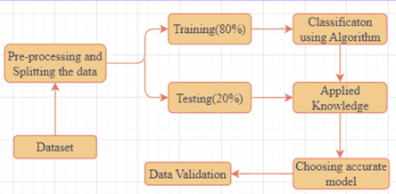
Fig. 1. - Flowchart of the System
In Figure 1, our research focuses on predicting four interconnected diseases: Heart Disease, Diabetes, Pneumonia, and Brain Tumors. First, we import many datasets from different sources, such as the PIMA dataset for diabetes, the UCI dataset for heart disease, and disease-specific datasets for brain tumors and pneumonia [4]. Data visualization provides information on the properties of each dataset. To provide reliable and high-quality data, further preprocessing includes data scaling, missing value management, and outlier identification. To enable precise model training and assessment, we subsequently divided the data into subsets for testing and training. We get the best precision in the classification of illnesses by employing methods such as Logistic Regression, Support Vector Machines, and Decision Trees [5]. User-friendly access to model results is ensured via integration with the Django framework, providing early disease prediction and improved patient outcomes for Heart Disease, Diabetes, Pneumonia, and Brain Tumors.
  - IMPLEMENTATION
- SVM (Support Vector Machine) algorithm
SVM works as follows:
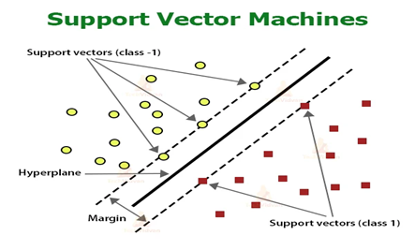

Fig. 2. - SVM Workflow
Step 1: SVM starts by choosing the appropriate kernel and parameters and identifying the type of classification problem (binary or multiclass) [14].
Step 2: The algorithm identifies the best-dividing line, called a hyperplane, to categorize the data points into distinct groups. It prioritizes creating a wide separation between these groups, ensuring a clear distinction [14].

w^{T}(x) + b = 0

Step 3: Each support vector has the biggest margin of the related class, and the SVM determines which support vectors are closest to the data points on the decision border [14].
Step 4: In order to classify new data points and create predictions, the SVM looks at the sign of the distance between the data point and the hyperplane to identify which side of the hyperplane the data points lie on [14].
Step 5: The SVM model is then ready for use, with its decision boundary effectively separating the classes [14].

- Logistic Regression Algorithm
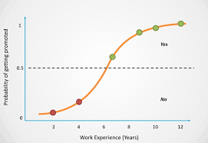

Fig. 3 - Logistic Regression Example (Graph of Work Experience in years vs Probability of getting promoted)
Step 1: Logistic Regression commences by selecting the relevant features and preparing the dataset [15].
Step 2: It calculates the log odds of probability that a data point belongs to a specific class. This log-odds function is known as the logistic function (sigmoid function) [15].
Step 3: Logistic regression uses optimization techniques to estimate the coefficients (weights) of each feature. These coefficients represent the contribution of each feature to the log-likelihood [15].
Step 4: To classify new data points, the model calculates the log probability of belonging to a given class and then uses a logistic function to transform the probabilities of those log probabilities [15].
Step 5: The model assigns new data points to the class with the highest probability, making it a valuable tool for binary classification tasks [15].

- Decision Tree Algorithm
The operation of the decision tree is as follows:
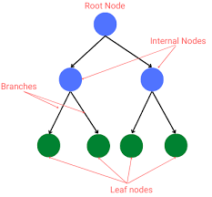

Fig. 4 Decision Tree Structure
Step 1: The most suitable attribute is first chosen to serve as the decision tree's root node. To achieve the highest level of classification purity, this feature is chosen using a number of factors, including Gini additive and information gain [15].
Step 2: The tree then branches into subtrees, each representing a specific attribute value. This process is applied recursively to each attribute value, resulting in a hierarchy of nodes [15].
Step 3: Until a halting condition is satisfied, such as a particular depth or a minimal quantity of data points at each leaf node, decision trees keep segmenting the dataset [15].

E = -p*log2(p) – q*log2(q)

Step 4: The built tree is prepared for forecasting. Based on the values of its attributes, a newly inserted data point navigates the tree's branches until it reaches a leaf node. The leaf node's class label serves as the data point's prediction. When combined, these algorithms enhance a multi-disease prognostic system's comprehensive analytical and forecasting powers, enhancing its capacity to reliably and effectively identify illnesses such as brain tumors, diabetes, pneumonia, heart disease, and other ailments [15].

- Random Forest Algorithm
The operation of the decision tree is as follows:
Step 1: Choose random samples from the given training data or set [16].
Step 2: For each training set of data, the algorithm will build a decision tree [16].
Step 3: The decision tree will be averaged to determine the winner [16].
Step 4: The final outcome will be selected on the basis of most votes received [16].
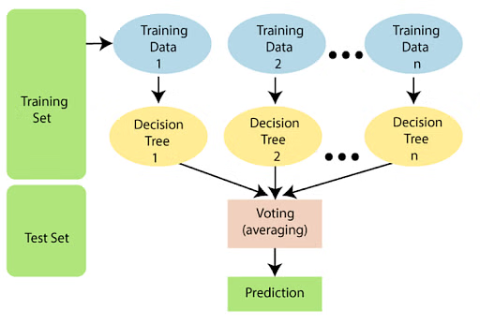
Fig. 5 Working of Random Forest Algorithm
We refer to this combination of many models as an ensemble. The ensemble consists of two techniques:
Bagging: Bagging is the process of separating out a distinct training subset using replacement from sample training data. The result is determined by a majority vote [16].
Boosting is the process of combining weak learners with strong learners by building successive models until the greatest accuracy model is achieved. For instance, ADA and XG boost [16].

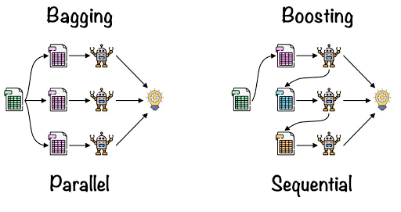

Fig. 6 Bagging and Boosting Model
  - USE CASE
- Cost savings: Early illness identification enables more economical treatments and treatment, which lessens the financial strain on people and health systems. Effective diagnostic procedures cut costs, which benefits patients as well as healthcare providers.
- Boost customer service: Proactive and timely patient treatment is ensured by early illness prediction, which enhances the patient experience in general. Patients like customized and data-driven healthcare because it results in better decisions and individualized care.
- Enhancing cooperation: Since many illness prediction systems enable healthcare providers to collaboratively evaluate a patient's health from several angles, they promote cooperation among them. A more comprehensive picture of a patient's health results from information sharing and analysis throughout medical teams, enabling better-informed decision-making.
- Increasing flexibility: The therapeutic choices available through these systems are flexible. Medical professionals can customize therapy to diseases, in addition to offering a flexible method of patient care. Based on the projections, the patient himself has the chance to make preventative decisions and lifestyle adjustments.
- Risk reduction: Preventive care and early identification lower the chance of complications and disease development, as well as lower mortality. By identifying high-risk patients and more wisely allocating resources to manage and reduce possible health concerns, risk-sharing benefits healthcare providers. To sum up, a multi-disease prognosis offers relief and lowers expenses.
- RESULT ANALYSIS
We are successfully building a system that predicts more than one disease with high accuracy. It is also easy to use. We achieve design accuracy as follows:

Brain Tumor Prediction:
1. Accuracy: Approximately 99%
2. Algorithm Used: CNN using Transfer Learning
3. Significance: The model successfully predicts brain tumors with a high accuracy rate, offering reliable diagnostic support for this critical medical condition.

Heart Disease Prediction:
1. Accuracy: 92%
2. Algorithm Used: Logistic Regression
3. Significance: The heart disease prediction model demonstrates a strong performance, providing accurate assessments of heart-related conditions for better patient care.
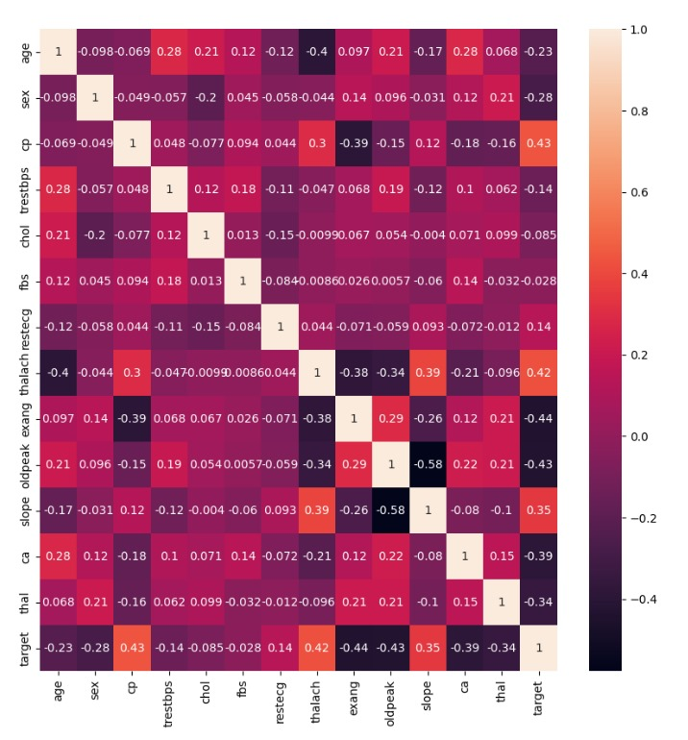

Fig. 7 Heart disease prediction heatmap
Diabetes Prediction:
1. Accuracy: 98.75%
2. Algorithm Used: Decision Trees
3. Significance: The diabetes prediction model excels with an impressive 98.75% accuracy, enabling early detection and effective management of diabetes, a prevalent and potentially severe disease.
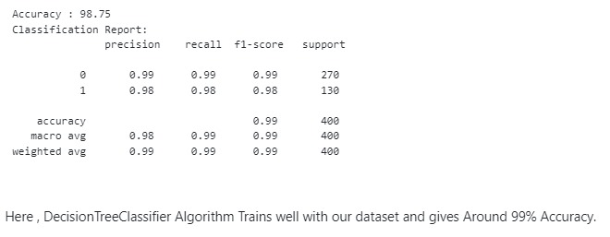
Fig. 8 Accuracy and classification report of diabetes prediction
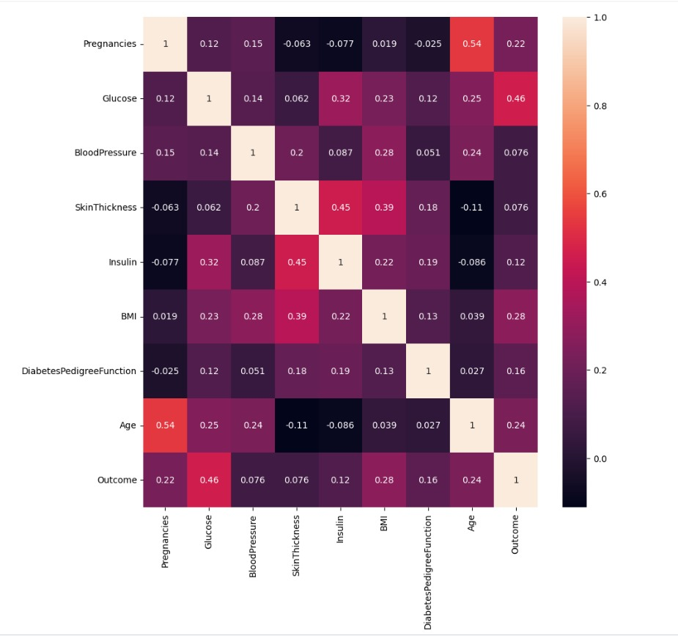
Fig. 9 Diabetes disease prediction heatmap
Pneumonia Prediction:
1. Accuracy: 97%
2. Algorithm Used: The ensemble ML models performed better in this study.
3. Significance: The prediction model aims to provide accurate assessments of pneumonia, which is crucial for timely treatment and management of respiratory conditions.
CONCLUSION AND FUTURE ENHANCEMENT. To sum up, our multi-disease prediction system correctly detects heart disease, diabetes, brain tumors, and pneumonia by fusing cutting-edge machine learning algorithms with intuitive user interfaces. Our approach has the power to completely transform the way healthcare is delivered by expediting diagnosis and enhancing patient care. Proactive healthcare management and improved patient outcomes are possible thanks to its high accuracy rates and continuous improvements. In the future, disease prediction models will prioritize openness through explainable AI, combining data from several medical sources for real-time monitoring and customized therapy recommendations.

References
- Chaudhari, Sahil, Prathamesh Deo, Purvaja Deshmukh, Aman Deshpande, Priya Shelke, and Abhijit Chitre. "Multiple Disease Prediction Using Machine Learning Algorithm." In 2023 7th International Conference On Computing, Communication, Control And Automation (ICCUBEA), pp. 1-6. IEEE, 2023.
- Kiruthiga, S. "Doctormate-An Early Disease Prediction Approach using Multiple Machine Learning Algorithms." In 2023 Second International Conference on Electronics and Renewable Systems (ICEARS), pp. 1276-1282. IEEE, 2023.
- Mahajan, Palak, Shahadat Uddin, Farshid Hajati, and Mohammad Ali Moni. "Ensemble Learning for Disease Prediction: A Review." In Healthcare, vol. 11, no. 12, p. 1808. MDPI, 2023.
- Singh, Pritpal, and Ishpreet Singh Virk. "Heart Disease Prediction Using Machine Learning Techniques." In 2023 International Conference on Artificial Intelligence and Smart Communication (AISC), pp. 999-1005. IEEE, 2023.
- Sidana, Khushi. "Prediction of Diabetes using Machine Learning Algorithms." In 2023 11th International Conference on Internet of Everything, Microwave Engineering, Communication and Networks (IEMECON), pp. 1-6. IEEE, 2023.
- Pentela, Ujwala, Anjali Nirupama Meesala, Deekshitha Karingula, Nandini Krishna Seelamsetti, and Swapna Veerlapalli. "Multiple Disease Prediction Based on User Symptoms using Machine Learning Algorithms." In 2023 International Conference on Distributed Computing and Electrical Circuits and Electronics (ICDCECE), pp. 1-6. IEEE, 2023.
- Shukla, Rahul, and Rupali Sawant. "Multiple Disease Prediction System Using Machine Learning." In 2023 International Conference on Electrical, Electronics, Communication and Computers (ELEXCOM), pp. 1-6. IEEE, 2023.
- Pious, Ignatious K., K. Antony Kumar, Y. Cephas Soulwin, and E. Nipun Reddy. "Heart Disease Prediction Using Machine Learning Algorithms." In 2022 International Conference on Innovative Computing, Intelligent Communication and Smart Electrical Systems (ICSES), pp. 1-6. IEEE, 2022.
- Jan, Mustafa, Akber A. Awan, Muhammad S. Khalid, and Salman Nisar. "Ensemble approach for developing a smart heart disease prediction system using classification algorithms." Research Reports in Clinical Cardiology (2018): 33-45.
- Lai, Hong, Xu-Ying Li, Fanxi Xu, Junge Zhu, Xian Li, Yang Song, Xianlin Wang, Zhanjun Wang, and Chaodong Wang. "Applications of Machine Learning to Diagnosis of Parkinson’s Disease." Brain Sciences 13, no. 11 (2023): 1546.
- Yu, Haonan. "Analysis and Prediction of Heart Disease Based on Machine Learning Algorithms." In 2023 8th International Conference on Intelligent Computing and Signal Processing (ICSP), pp. 1418-1423. IEEE, 2023.
- opisetti, Laxmi Deepthi, Srinivas Karthik Lambavai Kummera, Sai Rohan Pattamsetti, Sneha Kuna, Niharika Parsi, and Hari Priya Kodali. "Multiple Disease Prediction System using Machine Learning and Streamlit." In 2023 5th International Conference on Smart Systems and Inventive Technology (ICSSIT), pp. 923-931. IEEE, 2023.
- Kumar, Sunil, and Pooja Rani. "A Comparative Survey on Machine Learning Techniques for Prediction of Liver Disease." In 2023 6th International Conference on Contemporary Computing and Informatics (IC3I), vol. 6, pp. 1796-1801. IEEE, 2023.
- Li, Lan, Shaobin Ma, and Yun Zhang. "Optimization algorithm based on genetic support vector machine model." In 2014 Seventh International Symposium on Computational Intelligence and Design, vol. 1, pp. 307-310. IEEE, 2014
- Manvitha, T., and K. Sashi Rekha. "Improved Accuracy for prediction of leaf wetness using Logistic Regression algorithm compared with Decision Tree algorithm." In 2023 Eighth International Conference on Science Technology Engineering and Mathematics (ICONSTEM), pp. 1-5. IEEE, 2023.
- Yuan, Dong, Jian Huang, Xu Yang, and Jiarui Cui. "Improved random forest classification approach based on hybrid clustering selection." In 2020 Chinese Automation Congress (CAC), pp. 1559-1563. IEEE, 2020.

